Stage 4: Annual totals & Filter

We now have a four annual time series tracking departures and passengers for F Class in total at 813 airports in the United States. The files (for pax) look like this:

We now have next final two steps to take. First one is to create annual totals for each year (2019, 2020, 2021, 2022) and then filter the dataset down to airports excluding Alaska, Hawaii, Puerto Rico, Virgin Island and Trust territories and then include only airports that had more than 10,000 annual departing passengers either in 2019 or 2022. This accomplished in the notebook annual_totals_pax

1) Using the list of airports in 'airport_codes_master_analysis.csv' it loops through the annual time_series_pax_airport_{year} files and creates an output_df dataframe with annual level data on 813 (some have passenger data only for some years)

2) As an intermediate step it saves the annual totals as 'total_annual_pax_airports.csv'

3) It then takes output_df and excludes Alaska, Hawaii, Puerto Rico, Virgin Island and Trust territories and includes only airports that had more than 10,000 annual departing passengers either in 2019 or 2022.

4) Output_df is now down 355 airports. The notebook saves it as 'above_10K_total_annual_pax_airports.csv'

5) One important final step: city of Williston is represented in the data by two airports: Sloulin Field and Williston. That is because Sloulin was closed in 2019 and the new Williston replaced. It is logical that Williston is represented only by a single airport, and to make numerical analysis meaningful:

1. Sloulin’s data for 2019 must be added to Williston’s data
2. Sloulin must removed, and the result is 354 airport’s

This is done by hand in Excel, and the output file is saved by the same name.

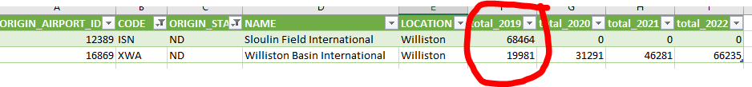



Williston correction must be always done when raw data is processed to this point and you’re creating a baseline dataset for the 354 airports to be analyzed and processed. The matter is discussed in detail in the Williston_update Word document.

7. Save the list as above10K_total_annual_pax_airports.csv. You have the annual passenger totals for the 354 airports.

Create a reference list of above10K airports for future use

1. Remove all other columns except ORIGIN_AIRPORT_ID and CODE, and you have list of the 354 airports. You can use to create dataframes in pandas when you want to filter raw/processed data to created datasets exclusive to the 354 airports. I created two lists, narrow above10K_airports_list.csv with just ORIGIN_AIRPORT_ID and broad with all the airport data above10K_airports_list_broad.csv

Create annual totals for departures at all airport and at 354

1. You start off with same procedure as for the pax, but because of the Williston correction, you need to do one manual correction to the output csv file

2. Use the code in the notebook total_annual_deps

The output will be two csv files, the intermediate with all the 813 airports and the 354 above10K airports.

3. Now you have to just the Williston correction, that is add the Sloulin’s 2019 figure to Williston’s 2019 figure. Open both csvs, do the calculation, amend the Williston figure in above10K_total_annual_deps_airports and you’re done.

